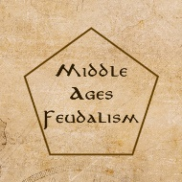

**Middle Ages Feudalism**

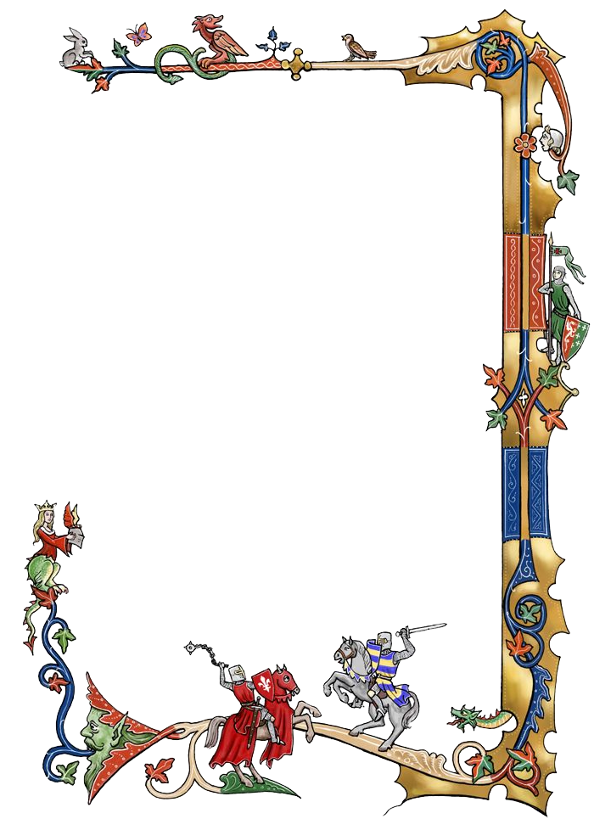.

Henry I, King of England, died on 1 December 1135.

England kingdom enter the period of civil war known as the Anarchy

The Anarchy was a civil war in England and Normandy between 1135 and 1153, which resulted in a widespread breakdown in law and order.

Player becomes the lord of middle ages.

Player need to Expand the territory and become the Legal heir.

* A tweet length description of the game

Build your Manor. Develope your Manor. You are the king of your kingdom!

#Destiny creator

#Chivalry

* A logo for the game

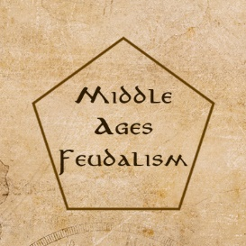

* A ‘brand image’ (or image set) for the game

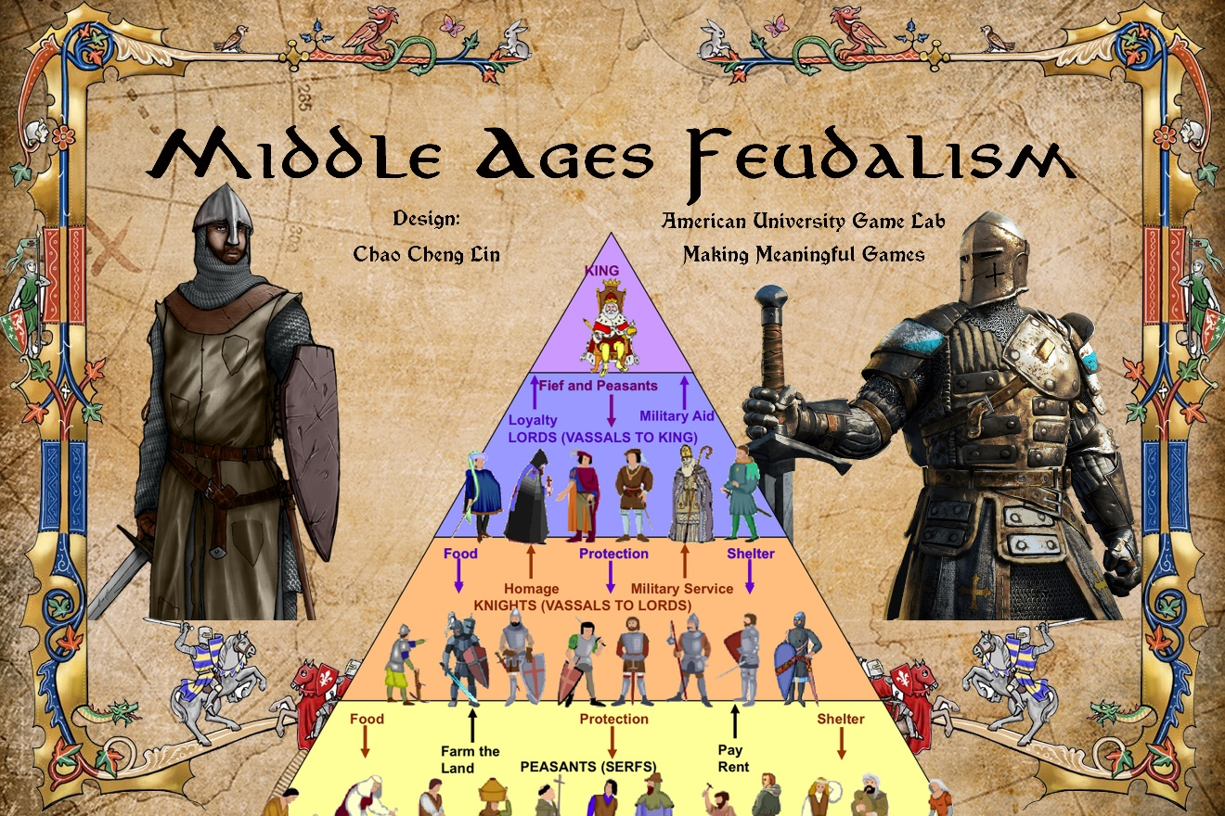

* A selection of screenshots or photos of the game being played

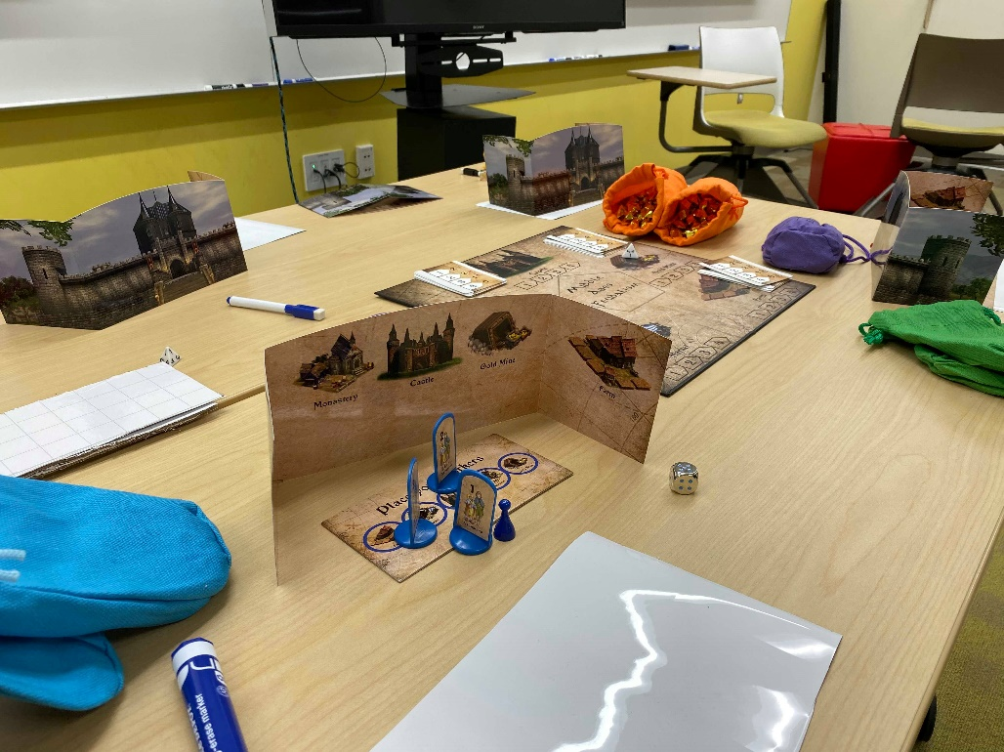

Player setup: using Player Screen to hide their Rectangle Game Tiles, resources, and three Plastic Pawns.

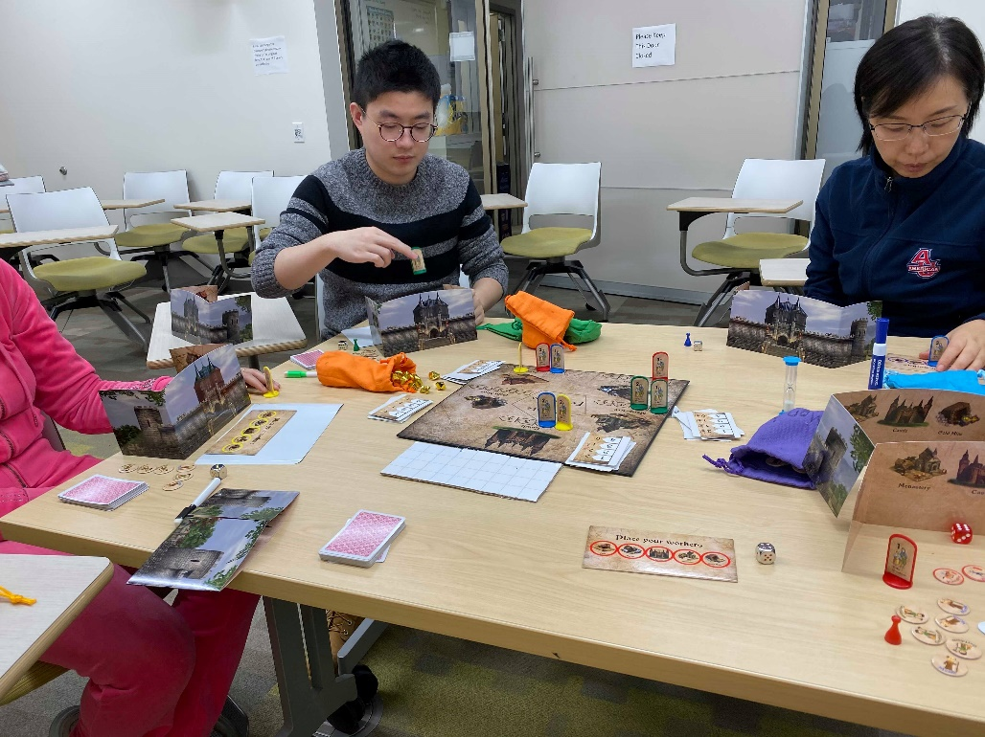

Player are placing workers and choose the priority of the resources.

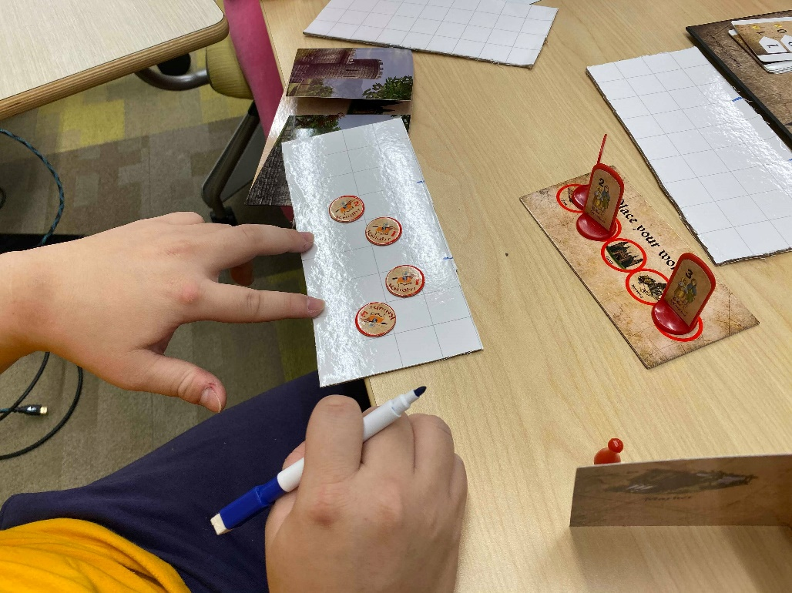

Player are preparing the war (Using the War tactic board)

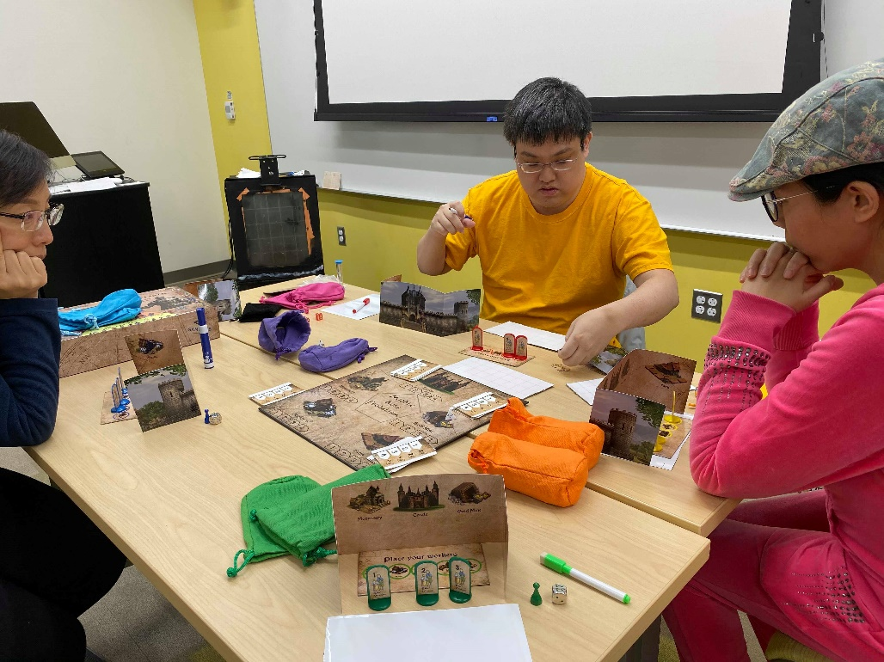

Every end of rounds, players need to provide the food to rhe residents of their manor.

**Video 1:** <https://youtu.be/tCAnCuItxDQ>

**Video 2:** <https://youtu.be/-ro_pqInM7k>

* A 1-2 sentence description

Players need to Expand the territory and become the Legal heir of the kingdom.

* Why’s meaningful?

|  |  |
| --- | --- |
| **In Game** | **Takeaway/** **Metaphor** |
| The order of players is important, but the player who has more golds or serfdom will always be the first player of every round. | Unfair world (Rich get richer) |
| Players can join the war to defeat the player who has more power and wealth. | importance of cooperation |
| In the market, player can trade with the other players.  In the war, player can invite the other player to join the war. | Negotiation ability |
| Players need to place the workers to gain the resources. | Prioritize |
| Story (England kingdom, Henry I, and Federalism) | History education (Real history, person, and fact.)  Federalism is the important system in Europe in the middle ages. |